
Bodily Injury Chart
Member Name_________________________________ Date______________
Circle Area of Injury
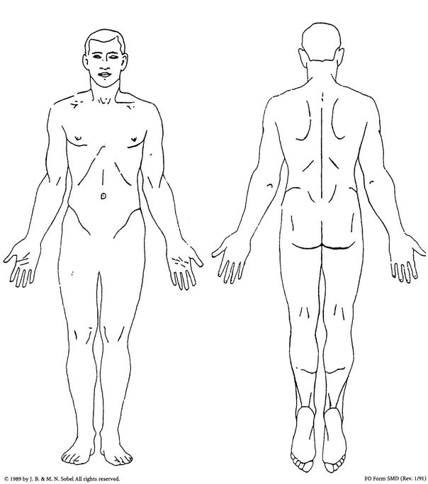
Description of Injury:

Provider Signature Print Providers Name

